
Calculation Policy
Brize Norton Primary School
We SHINE for ourselves and each other with kindness.
Strive, Help, Inspire, Nurture, Excel

Adopted by school LGB: | Brize Norton Primary School
Date: | March 2026
Review Date: | March 2029

 | EYFS | Year 1 | Year 2 | Year 3 | Year 4 | Year 5 | Year 6
Counting | Counting  forwards and  backwards in 1 s  to and beyond  10.  Counting  forwards and  backwards in  10s to one  hundred  Begin to count  in 5s and 2s  forwards and  backwards (if  able) | Counting in 1s on  and back to 100  with then without a  hundred square  Counting on and  back in 10s from  any number to one  hundred with then  without a hundred  square.  Counting forwards  and backwards in 2s  5s and 10s from 0. | Counting forwards and backwards in 10s and 1s to 100 and over (practice crossing 100 boundary)  Counting forwards and backwards in 2s 5s and 10s from any number (not always starting at 0)  Begin to count in 3s from 0 (with then without a hundred square) | Counting forwards and backwards in 1s, 10s, 100s from any 2 or 3 digit number crossing 1000 boundary.  Counting forwards and backwards in 2s 5s crossing 100 boundaries and from any number.  Counting forwards and backwards in in 3s, 4s and 8s from any number to 100 (with then without hundred square)  Count forwards and backwards in 50s and 100s. Make links between multiples of 2, 4, 8.  Count up and down in tenths seeing decimals notation. Use money. (10ps 0.10) | Counting forwards and backwards in 10s, 100s, 1000s from any 3 or 4 digit number crossing 10,000 boundaries.  Counting in tenths and hundredths crossing units boundary. (Use hundred square, bead string and coins, decimal and fraction cards.)  Counting forwards and backwards in multiples of 6, 7, 9, 11, 12  Make links between multiples of 3, 6, 12 and 2, 4, 8  Count in multiples of 25 relate to quarters.  Count backwards through zero into negative numbers | Counting in all powers of 10 crossing boundaries up to 1 million.  Counting in tenths, hundredths crossing boundaries. (Use hundred square, bead string and coins, decimal, fraction cards and percentage.)  Counting in thousandths crossing boundaries.  Counting in positive and negative numbers | Counting in all powers of 10 crossing boundaries up to 10 million.  Counting in tenths, hundredths and thousandths crossing boundaries.  Use negative numbers in context and calculate intervals across 0.
Addition | Exploring numbers to 5 in practical contexts. Recognising a number on my fingers/dice.  Beginning to recall number facts of all numbers to 5  For example 2+3=5  1+4= 5  2+2=4 | Starting at the bigger number and counting on using number line/cubes and fingers.  Learning addition facts of all numbers to 10 (e.g. 3+4=7)  Relate addition facts to 10 to those to 20.  4 + 6 = 10 14 + 6 =20  Begin to learn by heart addition facts which cross 10 e.g. 4 + 7 =11  Say 1 more than a given number | Adding three single digits (using known pairs)  Adding 9 or 11 using ten and adjust.  Using known number facts to 10 to calculate number facts to 20 e.g. 12+ 6  Learning by heart facts which bridge 10.  E.g. 5+7 | Continue to practice number facts which bridge 10 e.g. 8+5  Link to multiples of 10 e.g. 80+50  Continue adding 9 or 11 using 10 and adjusting.  Extend to adding 29 or 31 by adding nearest multiple of 10 and adjusting.  Mental addition dof 2 digit numbers (abstract)  Mental addition of multiples of 100s 10s or 1 to any 3 digit number.  Recognise pairs of multiples of 100 with a total of 1000  Recognise pairs of multiples of 5 with a total of 100 | Practice adding multiples of 10, 100 and 1000 using number bonds as base facts. (focus on crossing boundaries)  Find 1000 more than any given number.  Practice mental addition from Year 3- partitioning, using near multiples e.g. + 59 by adding 60 – 1  Add 91 by adding 90 and then add 1. | Practice adding powers of 10 using number bonds and place value facts., Add easy 2 and 3 digit numbers fluently. Add fractions where denominators are the same. | Practice adding powers of 10 using number bonds and place value facts., Use place value and number facts to solve problems in algebraic form.
Subtraction | Beginning to recall facts for numbers to 5  5-3 =2  4-2 = 2  Counting up to find a small difference to 5 or 10 (if able) Find one less than numbers to 20. | Starting at the bigger number and counting back using number line/cubes and fingers. Learning subtraction facts of all numbers to 10 (e.g. 3+4=7) Relate subtraction facts to 10 to those to 20. 4 + 6 = 10 14 + 6 =20 Begin to learn by heart subtraction facts which cross 10 e.g. 11 + 4 =7 Say 1 less than a given number and Counting up to find a small difference in numbers to 10 then 50 and 100 | Subtracting 9 or 11 using ten and adjust. Continue to learn and practice number facts to 10 to and 20 calculate number facts to 20 e.g. 12 – 8= Learning by heart facts which bridge 10. E.g. 12- 5= 7 Count up to find a small difference in numbers to 100 | Continue to practice subtraction facts which bridge 10 e.g. 8+5 Link to multiples of 10 e.g. 80+50 Continue subtract 9 or 11 using 10 and adjusting. Extend to subtracting 29 or 31 by adding nearest multiple of 10 and adjusting. Mental subtract of 2 digit numbers (abstract) Mental subtraction of multiples of 100s 10s or 1 to any 3 digit number. Count up to find small differences in numbers to 1000 | Practice subtracting multiples of 10, 100 and 1000 using number bonds as base facts. (focus on crossing boundaries) Find 1000 less than any given number. Practice mental subtraction from Year 3- partitioning, using near multiples e.g. - 59 by subtracting 60 + 1 Subtract 91 by Subtracting 90 and then subtracting 1. Count up to find small differences in numbers to 10,000 | Practice subtracting powers of 10 using number bonds and place value facts. Subtract easy 2 and 3 digit numbers fluently. Subtract fractions where denominators are the same. Practice mental subtraction from Year 3 and 4- partitioning, using near multiples e.g. - 559 by subtracting 560 + 1 Subtract 901 by Subtracting 900 and then subtracting 1. Count up to find small differences in numbers to 1 million | Practice subtracting powers of 10 using number bonds and place value facts., Use place value and number facts to solve problems in algebraic form
Multiplication | Begin to learn by heart some doubles if able e.g. double 2 is 4 | Know by heart doubles of all numbers to at least 10 + 10 Begin to learn 10x table facts and link to counting in 10s | Learn 2x 5 x10 tablesspend at least a term learning each one (1 at a time) Practice doubles to 20 including those which require partitioning e.g. 14+14= | Learn 3x, 4x, 8x tables. Continue to practice 2x 5 x 10. Practice multiplying a number by 10 using practical resources (place value grids) Use times table facts and place value to multiply multiples of 10 and 100 e.g 2x 5 = 2x 50 = 100 | Learn 6x 7x 9x 11x 12x tables by heart (spend a term learning each one) Continue to practice the rest of the tables. Multiply numbers by 10 and 100 using place value grids. Include decimals to 1 place. Use times table facts and place value to multiply multiples of 10 and 100 e.g.Use chains: 2 x 0.5 = 1 2x 5 = 10 2x 50 = 100 2x 500 = 1,000 2 x 5000 = 10, 000 | Apply all multiplication tables to 12 x 12 to calculating with powers of 10 and decimals. Multiply numbers by 10, 100 and 1000 including to decimals with 3 decimal places | Apply all multiplication tables to 12 x 12 to calculating with powers of 10 and decimals. Multiply numbers by 10, 100 and 1000 including to decimals with 3 decimal places Use place value and number facts to solve problems in algebraic form
Division |  | Halve even numbers to 20. Begin to learn 10x table division facts and link to counting in 10s. | Practice division facts for 2x 5x 10x tables relating to multiplication and fractions. Know halves of all numbers to 20. | Relate division facts for 3x 4x 8x to multiplication facts. Continue to practice division facts for 2x 5x 10. Practice dividing a number by 10 using practical resources (place value grids) | Practice division facts for 6x 7x 9x 11x 12 alongside learning multiplication facts and link to fractions. Divide numbers by 10 and 100 using place value grids. Include decimals to 1 place. Use times table facts and place value to multiply multiples of 10 and 100 e.g.Use chains: 1÷ 2 = 0.5 10 ÷ 2 = 5 100÷ 2 = 50 1000 ÷ 2 = 500 10,000÷ 2 = 5000 | Use the rapid recall of table and division facts to 12 x 12 to identify prime numbers to 100. Divide numbers by 10, 100 and 1000 including to decimals with 3 decimal places. Apply knowledge of table facts and place value to divide multiples of 10, 100, 1000, 10,000, 100,000 e.g. 500,000 ÷ 50= | Use the rapid recall of table and division facts to 12 x 12 to identify prime numbers to 100. Divide numbers by 10, 100 and 1000 including to decimals with 3 decimal places. Apply knowledge of table facts and place value to divide multiples of 10, 100, 1000, 10,000, 100,000 e.g. 500,000 ÷ 50= Use place value and number facts to solve problems in algebraic form.
Rounding | Exploring on number tracks/lines is 6 closer to 10? | Practice number boundaries 16 lies between 10 and 20. Say hello to the next 10 or the 10 before.. | Practice number boundaries 23 lies between 20 and 30. | Practice number boundaries. 130 lies between 100 and 200. 23 lies between 20 and 30. | Round numbers to the nearest 10 and 100 and 1000 Practice number boundaries 4500 lies between 4000 and 5000 4550 lies between 4500 and 4600 | Round numbers to the nearest 10, 100, 1000, 10,000 and 100, 000 Practice number boundaries 45000 lies between 40000 and 50000 45500 lies between 45000 and 46000 | Round any number to the nearest required degree of accuracy.
Properties of number | Use correct mathematical language at all times when describing number. Larger, smaller, ones etc | Identify multiples of 10. | Use terms multiples and factors alongside learning times tables. | Use terms multiples and factors alongside learning times tables. | Use terms multiples and factors alongside learning times tables | Use terms multiples and factors alongside learning times tables. Learn square numbers Learn cube numbers Recall prime numbers to 19 and identify to 100 Identify multiples of factors, including factor pairs, prime factors and common factors of two numbers | Identify common factors, common multiples and prime numbers
Fractions, decimals and percentag |  |  | Find 1/10 , 1/5 1,2 of numbers relating to times tables | Find 1/3 ¼ 1/8 of numbers relating to times tables. Begin to add decimals with 1 digit using place value (no crossing boundaries) use number facts. | Find unit fractions of numbers based on the times tables they are practicing. Add and subtract numbers with 1 decimal place mentally | Begin to know equivalence of basic fractions, decimals and percentages. 10% 25% 50% 75% ¼ 1/3 1/5 1/10 1/100 1/1000 Mentally add simple decimals to 1 and 2 places. | Know equivalence of basic fractions to decimals and percentages 10 % 25% 50% 75% ¼ 1/3 1/5 1/10 1/100 1/1000 Mentally add simple decimals to 1,2 and 3 places.

Addition

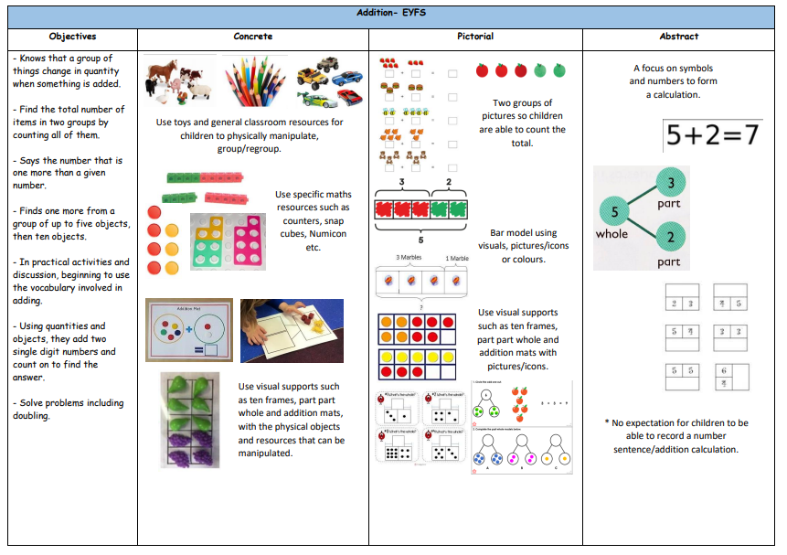

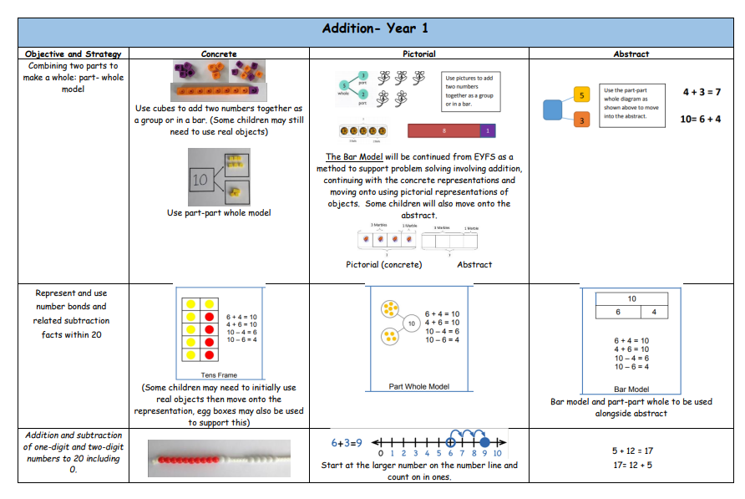

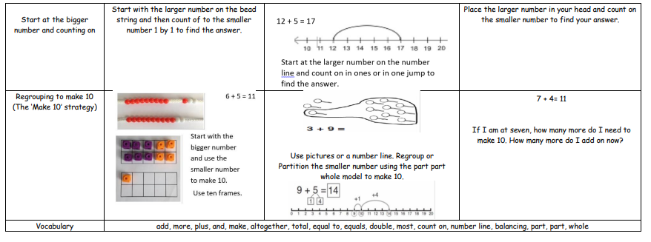

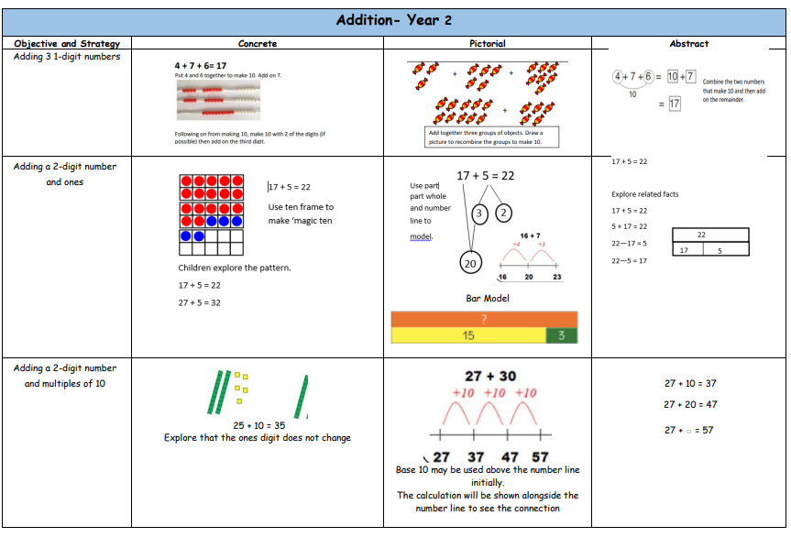

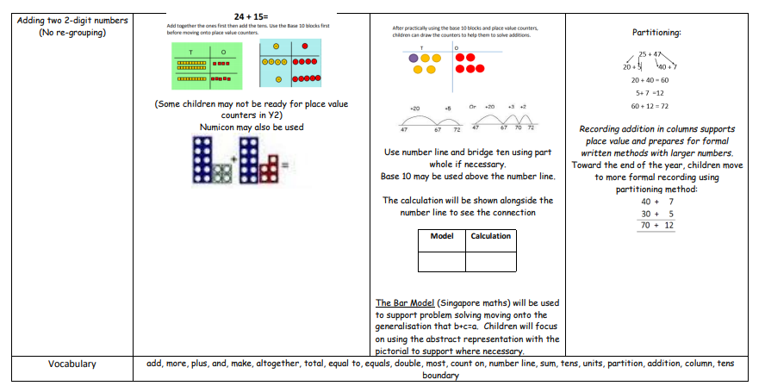

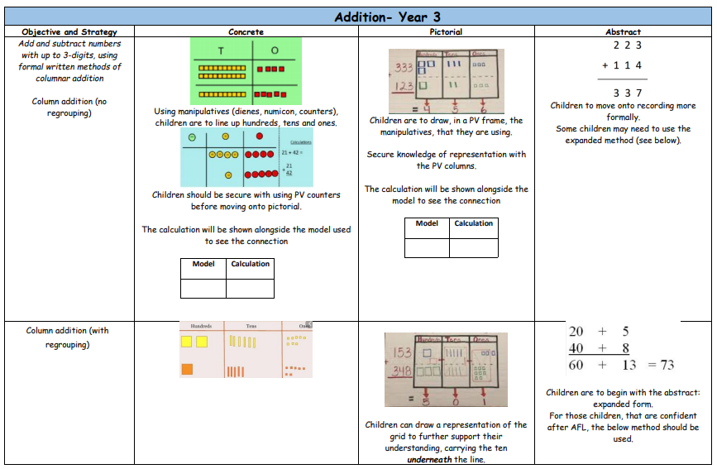

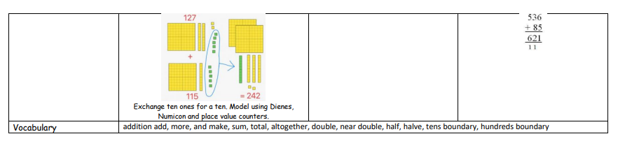

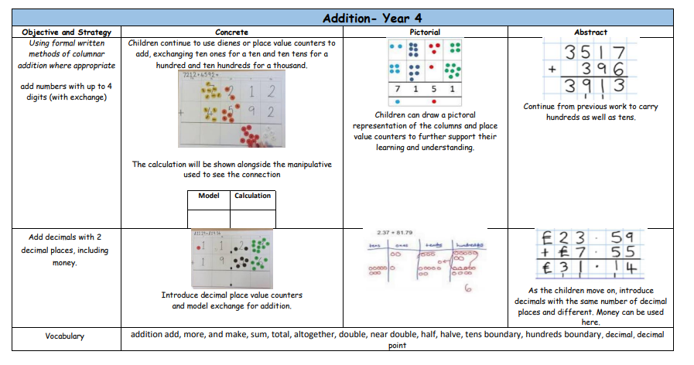

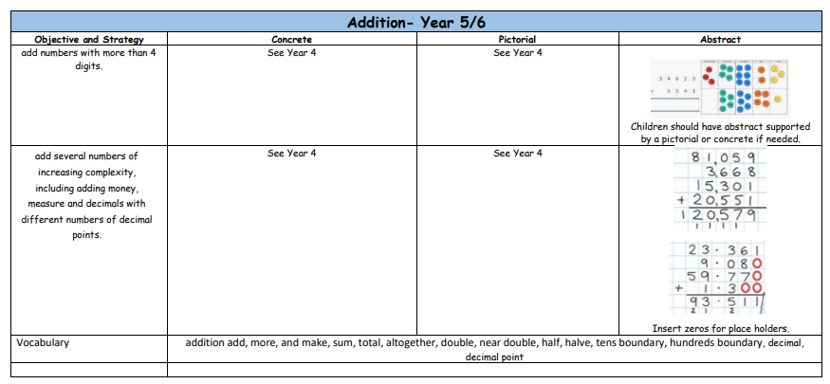

Subtraction
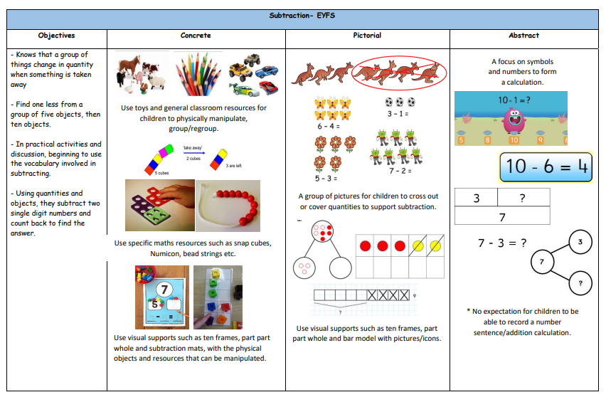

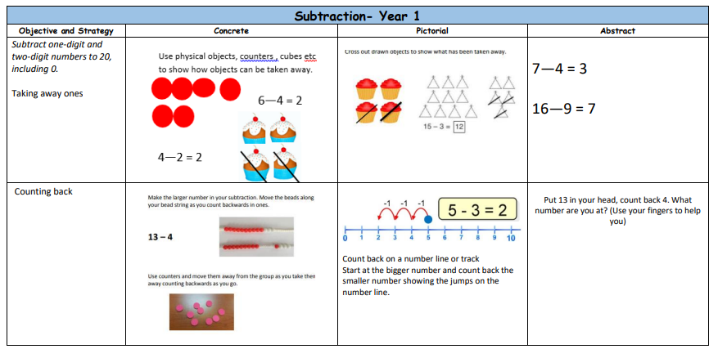

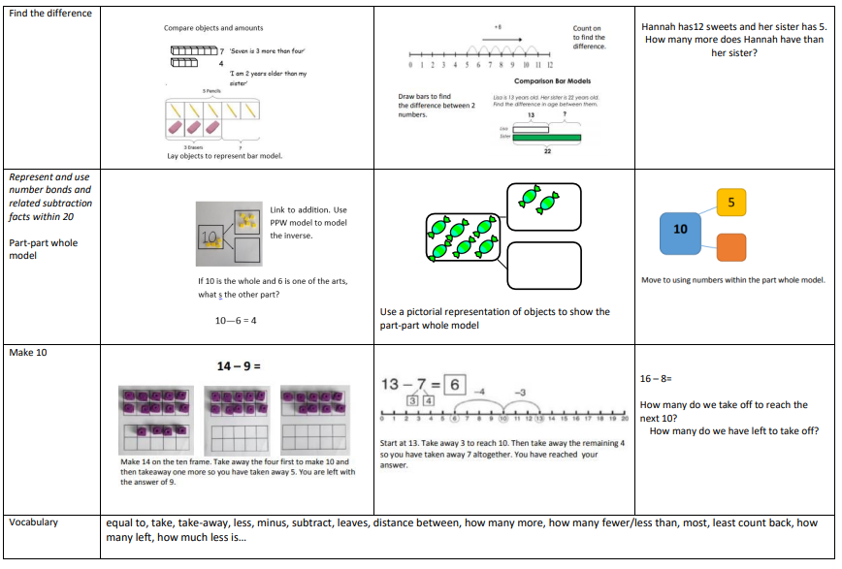

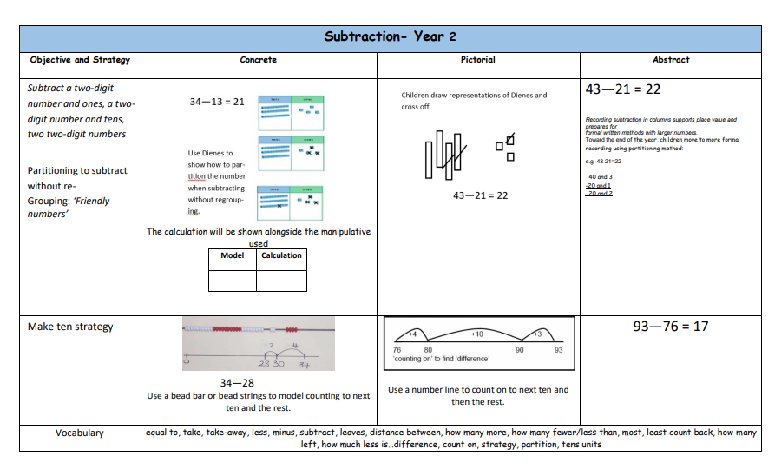

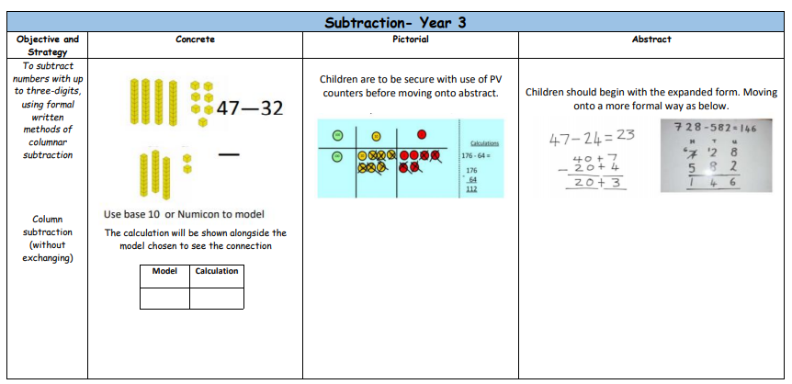

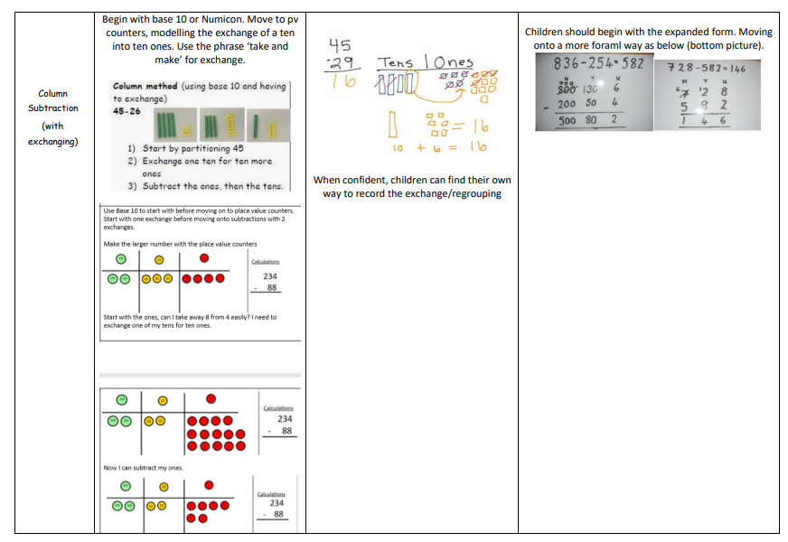

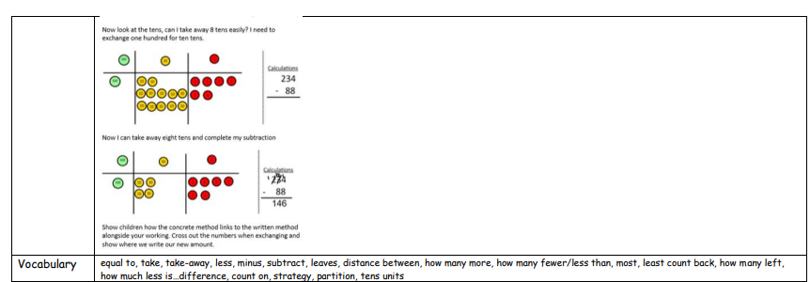

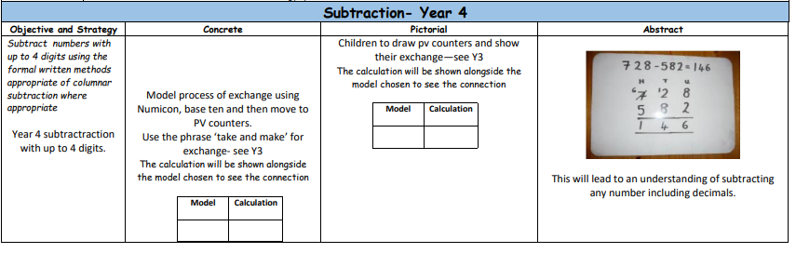
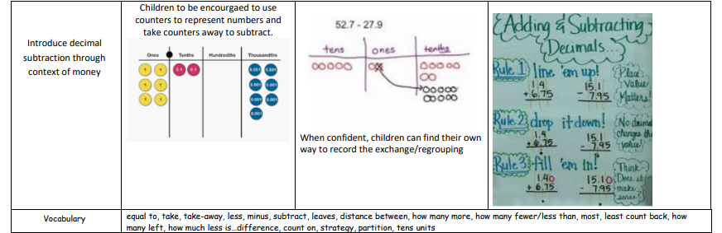

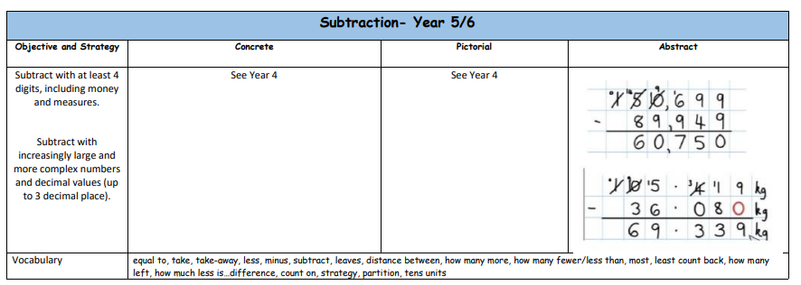

Multiplication
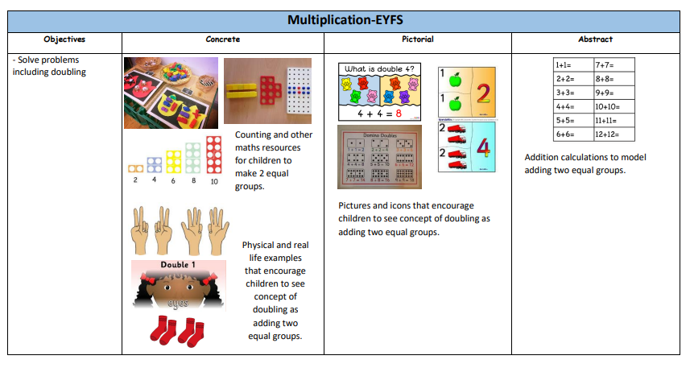

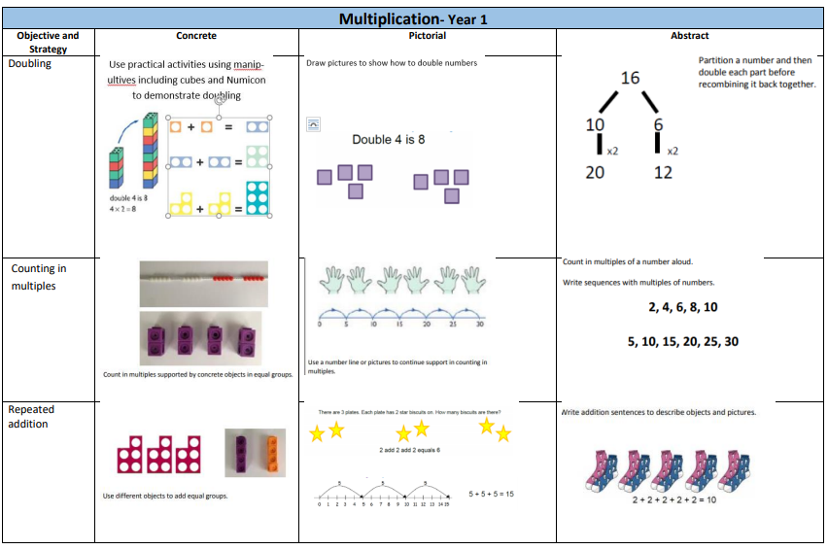

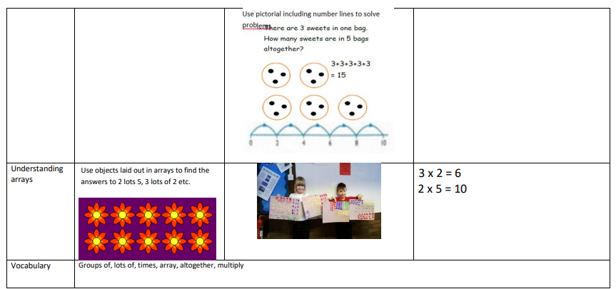

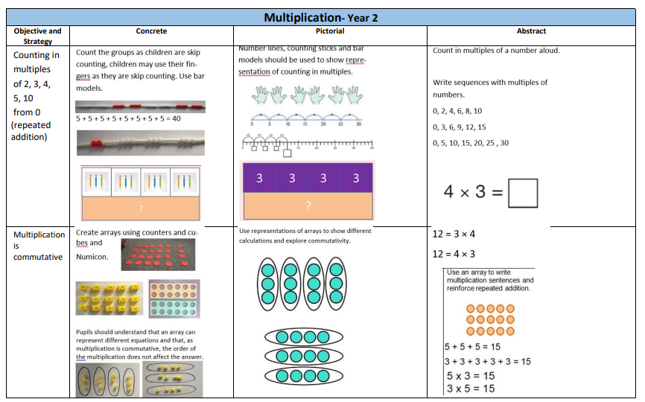

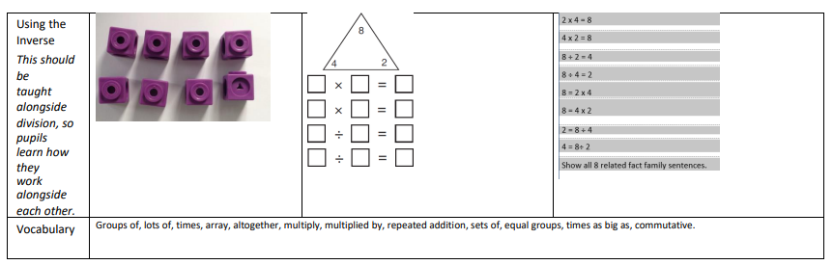

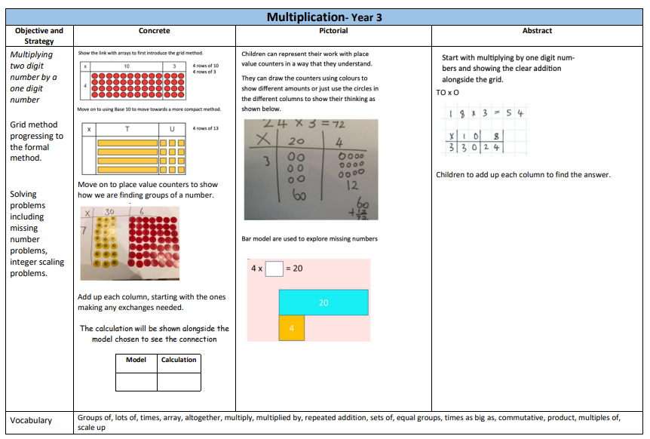

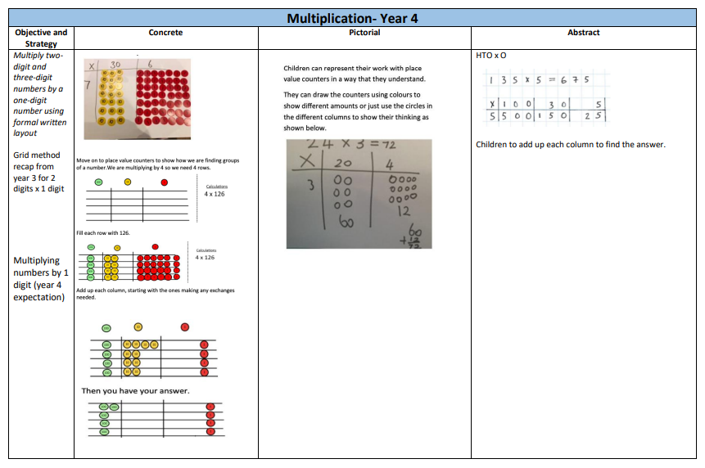

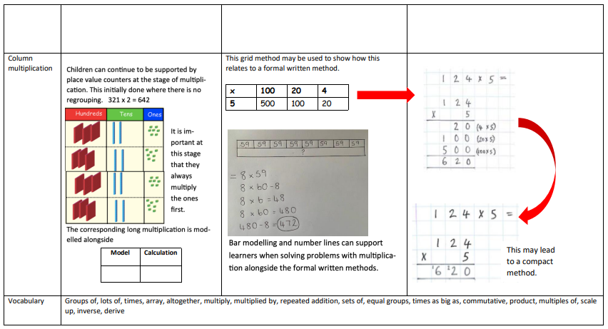

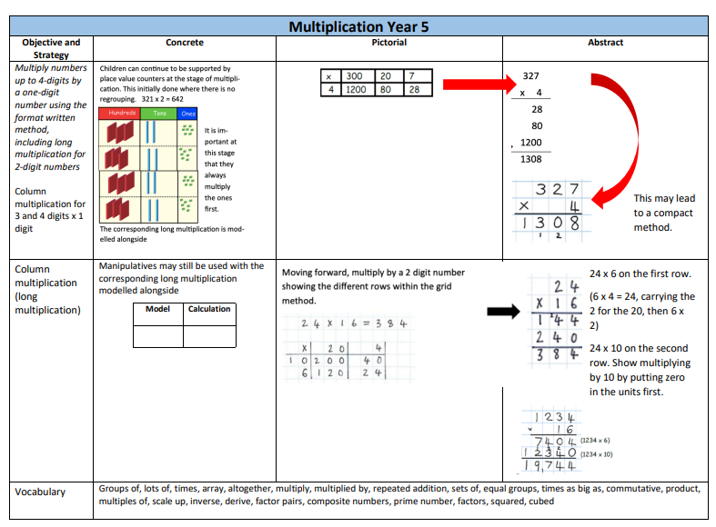

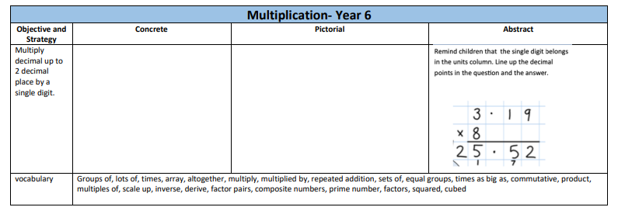

Division


