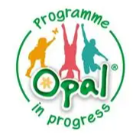 |  | We are proud to be an OPAL school.. | OPAL  Outdoor play and learning  Brize Norton Primary School’s commitment to supporting our children through high-quality play provision.
  What our children say:  “There’s so much to do and choose from.”  “I love playtimes. I like playing the sandpit and on the wheels.”  What our parents say:  “Real mix of ages playing together and lots of spaces to play.”  “I liked that resources are available in all areas of the playground.” |  | 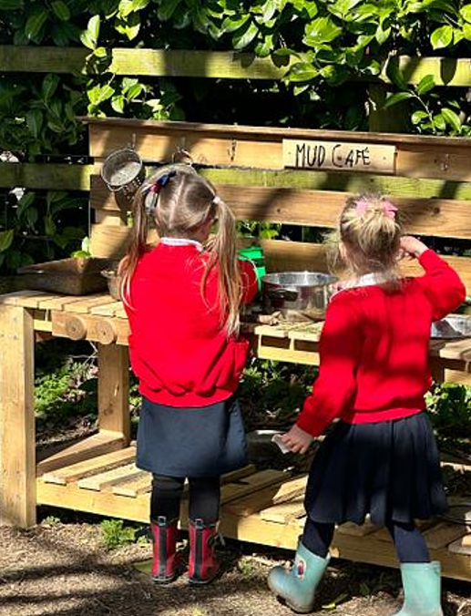 | 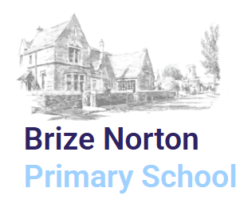  We SHINE for ourselves and each other with kindness.  Strive, Help, Inspire, Nurture, Excel
Brize Norton Primary School
Station Road
Brize Norton
OXON
OX18 3PL

Office.2250@brize-norton.oxon.sch.uk

01993 842488

•••

🧠 Why OPAL Matters  OPAL is built on the principle that play is the “unteachable curriculum”—the way children learn things that cannot be taught directly, such as:  Problem‑solving  Social skills  Emotional resilience  Risk assessment  Creativity | The Core OPAL Play Types  1. Physical Play  Active, whole‑body movement that builds strength, coordination, and confidence.  Examples: running, climbing, jumping, rolling, swinging, balancing.  2. Creative Play  Using materials to invent, build, or transform things.  Examples: loose‑parts construction, den building, mud kitchens, junk modelling.  3. Social/Imaginative Play  Children create stories, characters, and shared worlds.  Examples: role‑play, fantasy games, superheroes, shops, families, “schools”. | What is OPAL…  OPAL (Outdoor Play and Learning) is an award‑winning, whole‑school improvement programme that helps primary schools radically improve the quality of children’s playtimes.  Its core idea is simple but powerful: play is essential for children’s physical, social, emotional, and cognitive development, and schools can transform outcomes by treating play with the same strategic importance as teaching and learning. |   Miss Laura Nelson  OPAL Lead
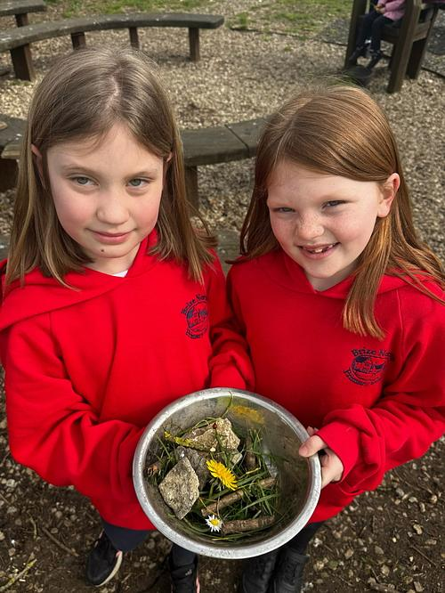 | 4. Exploratory Play  Investigating materials, textures, and  natural elements.  Examples: water play, sand, mud, sticks,  stones, ropes, sensory exploration.  5. Risk and Challenge Play  Children test their limits in safe but  challenging ways.  Examples: climbing high, balancing on  logs, using tools, rough‑and‑tumble.  6. Social/Cooperative Play  Working together, negotiating,  problem‑solving.  Examples: group building projects, team  games, shared imaginative worlds. | Why OPAL Encourages Many Play Types  OPAL’s philosophy is that children need a rich “play diet”, just like they need a balanced food diet.  A high‑quality OPAL playground allows children to choose from multiple play types every day, supporting:  Physical development  Emotional resilience  Social skills  Creativity  Problem‑solving  Independence | We are always looking for donations…  Kitchen items:  Plastic, wooden and metal pans and utensils, spatulas, spoons, whisks, funnels, colanders Jugs, cups, bowls, baking trays  Scrubbing brushes…  Old toys:  Farm animals, dinosaurs, teddy bears Toy cars, tractors, diggers, play garage  Sand toys - buckets, spades  Home and Office:  Computer keyboards and mice  Desk phones, mobile phones, old laptops

