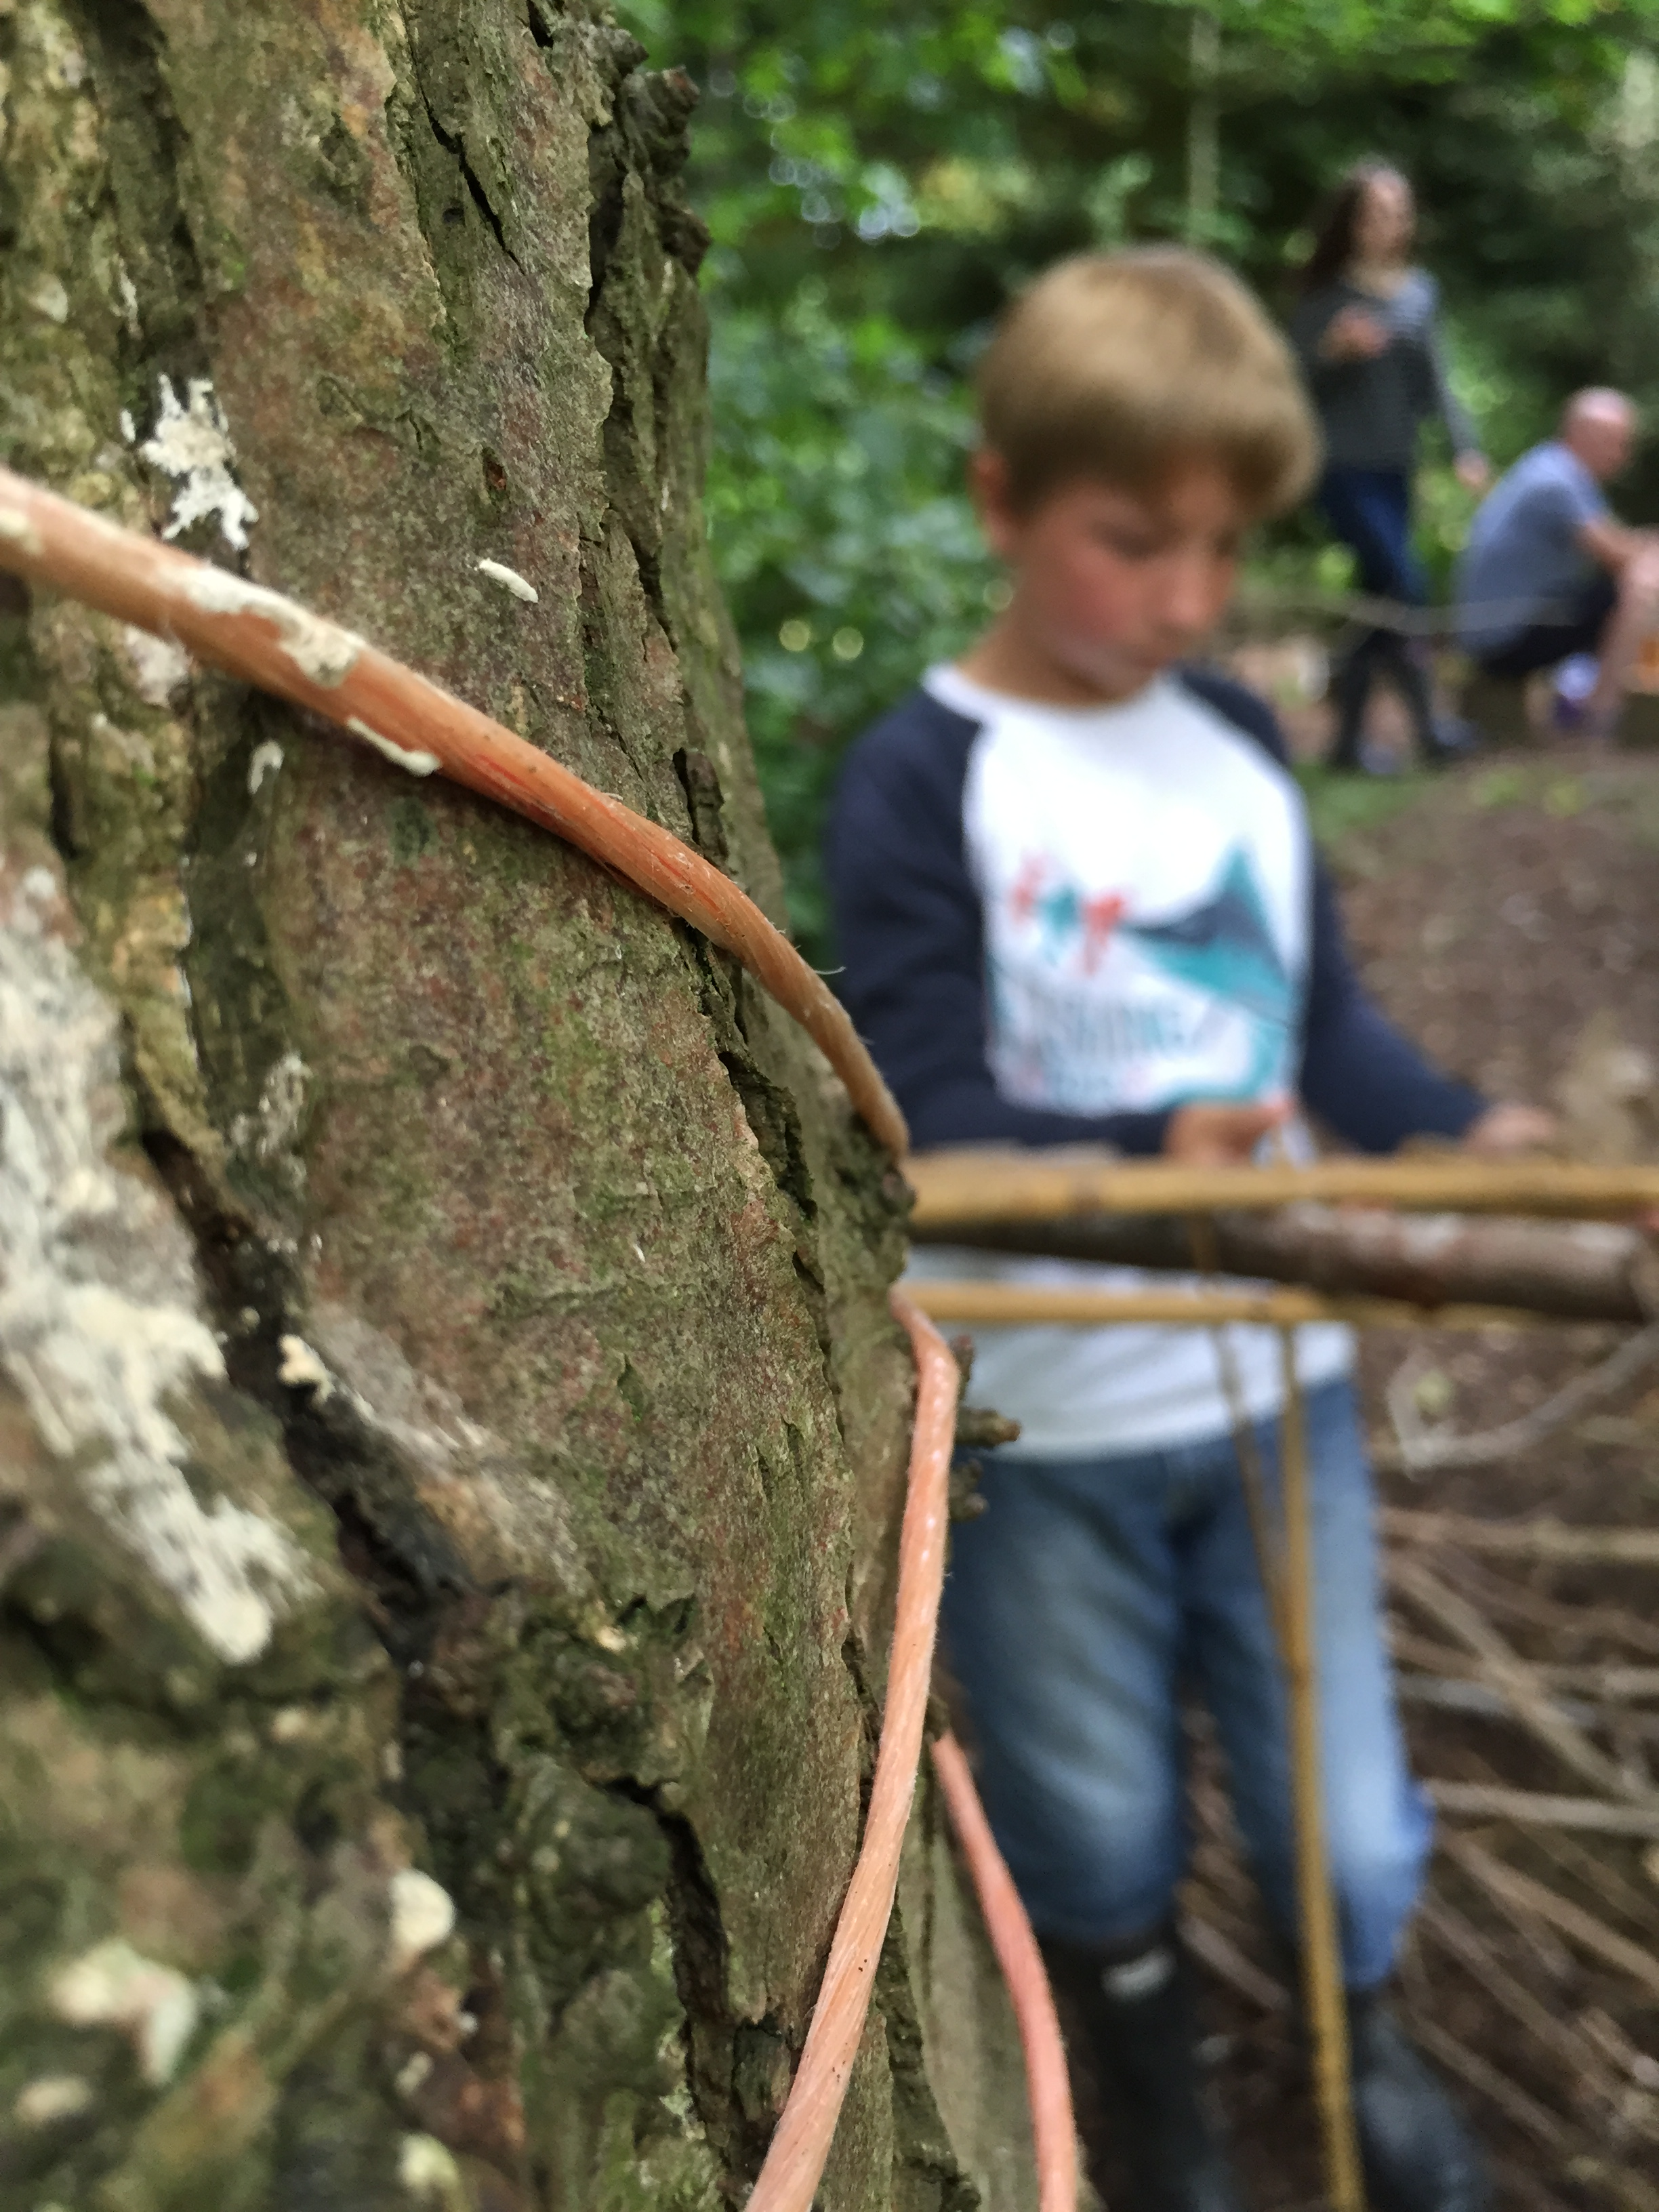
Brize Norton Primary

Forest School Handbook

Station Road
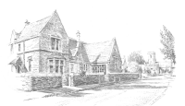
Brize Norton
Oxon OX18 3PL
01993 842488
www.bnschool.org
office.2250@brize-norton.oxon.sch.uk Headteacher Mrs Robyn Jones

Contents

Page
Our Forest School vision statement

Forest School Association Principles for Brize Norton Primary

Assessment for learning, recording and reporting

Behaviour

Clothing, personal equipment and weather

Communication Strategy

Complaints procedure

Compliance signature sheet for all regular accompanying adults

Confidentiality

Ecological impact assessment and three year woodland management plan including site maps

Equal opportunities at Forest School

First aid kit lists/Burns kit list

Health and Safety:
- Assessment recording and reporting
- Emergency action plan
- Lost children
- Risk assessments including site, natural and manmade hazards, child led and planned experiences
- Evidence of site checks (annual, termly and daily)
- Hygiene (including toileting, hand washing, snack time)
- Daily safety procedures
- Transport
- Practical skills including tools, fire and ropes

Insurance

Landowner agreement

Media
- Photograph permissions
- Video permissions

Medical records (for all members of the group)

Safeguarding including DBS checks, disclosures and accusations

Session routines

Sustainability

Appendix

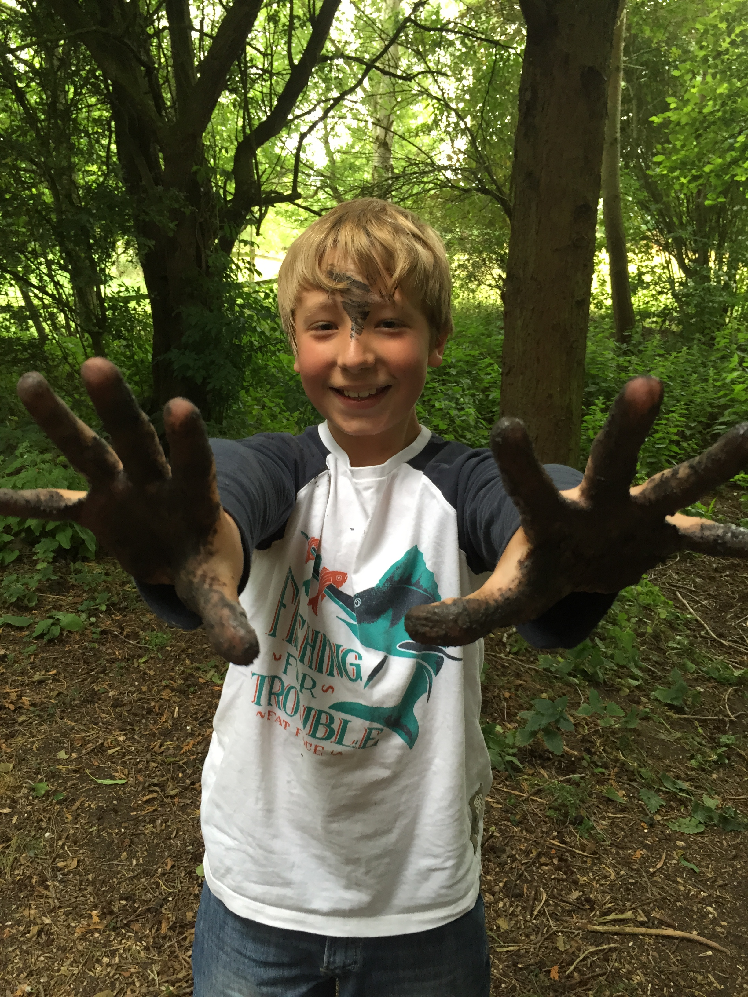

Our Vision

Our vision is to provide a unique educational experience and process that offers children the opportunity to succeed and develop confidence and self esteem through hands-on learning experiences in a woodland environment. We want children to have the freedom to be themselves; to be in charge of their learning, have fun, get dirty, laugh, take risks, make decisions, use tools, solve problems, achieve success, develop an understanding of the natural world and learn new skills that they will have for life.

Forest School Principles

Principle 1: Forest School is a long-term process of frequent and regular sessions in a woodland or natural environment, rather than a one-off visit. Planning, adaptation, observations and reviewing are integral elements of Forest School.
Foundation Stage will take part in Forest School sessions for one afternoon every week throughout the year. All other year groups will experience Forest School for one term/half term every year; each class will take part in the same term every year (where possible) so that, by Year 6, all children will have experienced seasonal and weather changes.
At Forest School, we want children to have the freedom to explore independently, so – before each session begins – the children will be made aware of where they can go and of any fixed boundary markers. Adults will have the opportunity to stand back and watch children from a distance in their play, and use this to help provide new opportunities that will build on what they have seen.

Principle 2: Forest School takes place in a woodland or natural wooded environment to support the development of a relationship between the learner and the natural world.
We are very lucky to have a small natural area on our school site where children will have the space and the freedom to explore, discover and be creative. We have a range of plants, trees and habitats – including a pond – that will motivate the children and provide opportunities for them to learn and gain an understanding of the natural world on their doorstep. The children will be sharing the environment with plants and animals so, they can investigate, learn and play on the understanding that they take care and remember to show respect to our Forest School site.

Principle 3: Forest School aims to promote the holistic development of all those involved, fostering resilient, confident, independent and creative learners
The children at Forest School will have many opportunities - from building shelters to playing with their friends - to develop and become resilient, confident, independent and creative learners. Taking the idea of building a shelter will give them the opportunity to work together, develop gross motor skills (collecting materials such as branches) build on intellectual skills (working out how to build a shelter and where to place the sticks!), language and communication skills in talking to each other about what they are doing, listening to instructions from an adult, asking for and responding to requests for help, emotional development through the sense of well-being that they may get from working as a team, self-esteem through achieving a goal and producing something they are proud of and social development through the negotiation, sharing and helping. To develop these skills with a real goal in mind is motivational for the children.

Principle 4: Forest School offers learners the opportunity to take supported risks appropriate to the environment and to themselves.
Children are free to explore as they wish, climb trees (with supervision), play in the mud, make rope swings or rope balance games and generally experience the woodland environment. Allowing the children to steer their learning and manage their own risks is a vital part of their development, building on their innate motivation, positive attitudes and/or interests. Children grow in confidence as they reflect and plan their own learning. Allowing them to problem solve, make mistakes and try again also builds on their resilience.
The children will have the opportunity to build fires and use tools in a controlled environment. They will learn how use both safely. Risk assessments will be carried out accordingly.

5. Forest School is run by qualified Forest School practitioners who continuously maintain and develop their professional practice.
Mrs. Rae, who has a Level 3 Forest School Leader qualification, leads Forest School. She is supported by 1/2 TA’s according to the class size. We also have several regular adult helpers so that our adult to learner ratio remains high. All adults have a DBS check and staff have up to date first aid qualifications; Mrs. Rae has a specific Forest School first aid qualification.

6. Forest School uses a range of learner-centred processes to create a community for development and learning
At Forest School, we want the children to be in charge of their learning. By giving them the freedom to do this, they will learn through play and naturally ask inquisitive questions. By giving the children time to reflect at the end of a session, they will have the opportunity to talk about things that they have leant or achieved as well as make suggestions about things that they may want to do next. Equally, the adults present will gain a clear understanding of each child through careful observations and will develop closer relationships built on trust. Using this knowledge, we can plan to steer, build on and stretch the children’s learning through the provision of resources in the following session.

- Assessment for learning, recording and reporting
During the sessions, adults will observe the children in their learning, which will feed into the planning of the next session. The children will also have the opportunity to reflect on their learning during or at the end of a session; they will be able to talk about something that they have enjoyed, something that they have learned or something that they would like to do as a result of that day’s activities. All of this information will help to plan the next session; to build on what they have done and enable children to have their learning extended.
Photographs and website posts help to document learning and are available for the class teacher and parents to see.

- Behaviour
At Brize Norton Primary, we want Forest School to be a positive experience for all involved. In addition to our school behaviour policy, we promote the idea of, ‘look after ourselves, look after each other and look after the world’; at the beginning of each session we will talk about what this means and how we can do this. Over the weeks, the children will have created their own ‘golden rules’ of Forest School, which are consistently reinforced, and will have a good understanding of the expectations.
During sessions, we want children to feel happy and confident. Therefore, we aim to give lots of positive reinforcement to all children to ensure they have a sense of achievement. On the occasion that a child loses focus and become disruptive, we will aim to re-engage them and make them feel included. However, if this fails to work and their actions become dangerous to themselves or others, the Forest School Leader (Alex Rae) will implement the school behaviour policy.

- Clothing
Forest School sessions go ahead all year round; Det finnes ikke dårlig vær, bare dårlige klær! (there is no bad weather, only bad clothing).
All children and adults that participate in Forest School must wear suitable clothing; long sleeves, long trousers and closed toe footwear (e.g. wellies) are recommended to ensure adults and children are protected from stings, scratches and bites – as well as being protected from tripping and things falling on toes. Depending on the weather, the following may be required:
Cold Weather – wearing layers provides insulation; vest, shirt, jumper, coat, scarves, hats, gloves etc.
Wet weather – waterproof trousers, waterproof coat with a hood
Hot weather – sunhat, sun cream

We will endeavour to have spares as we want all children to benefit from Forest School on a regular basis and do not want them to be excluded from sessions. However, in the event that a child does not have the appropriate clothing and we do not have any to lend, we have the right to exclude a child, for their own well-being.

Certain activities will require additional personal protective equipment (PPE), which we will provide. For example, when the children use certain tools, they will be required to wear a protective glove.
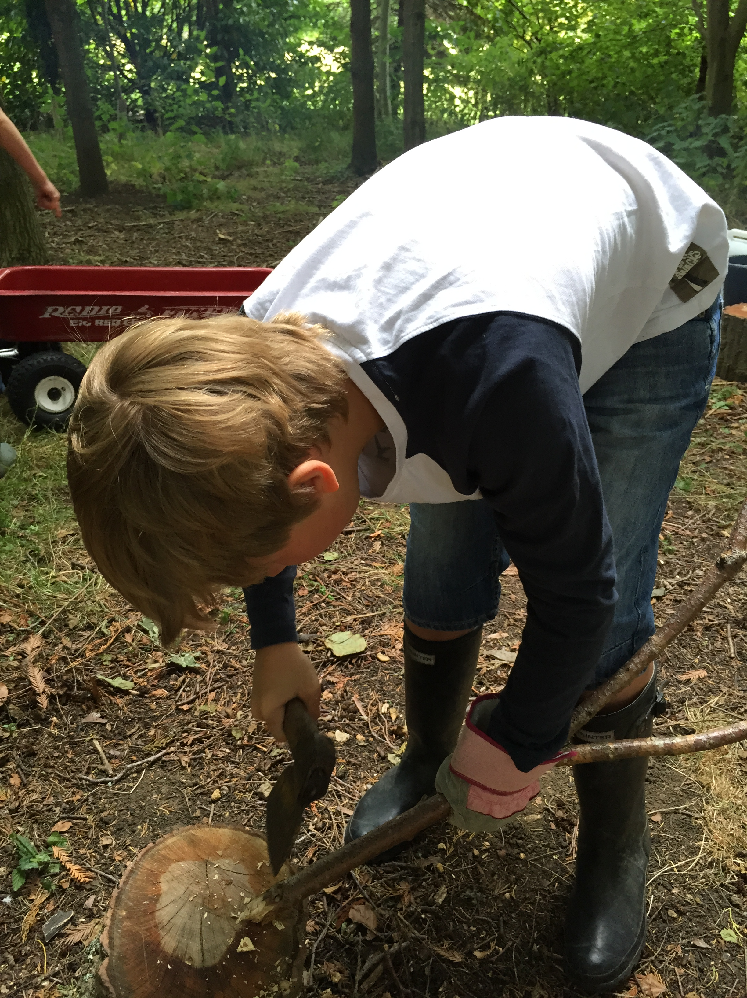

- Weather

We go out to Forest School in all weathers and temperatures. However, as part of the daily risk assessment, the Forest School Leader will consult an up-to-date weather forecast (Met Office). Should there be a risk of high winds, the Forest School Leader will complete a site check of the trees and branches. If necessary, the session will be moved out from under the trees into an open space where the risk is lowered. If lightning is forecast, the adults will be made aware and watch/listen carefully during the sessions for any signs. If a rumble of thunder is heard, the children will be quickly called together and safely taken inside.

- Communication Strategy
Parents
We will communicate to parents and guardians via an information leaflet and permission letter before Forest School starts; for Foundation children starting in September, this will be part of the welcome pack sent out in the summer term. We will inform them about what Forest School is and its benefits, as well as letting them know where and when it will take place, examples of activities and what they will need. Updates of what is happening in Forest School throughout the year will also be communicated via the school website. Photographs for the school website will only be taken of those children whose parents have signed the appropriate permission slip.

Children
At the beginning of every Forest School session, we will talk to the children about Forest School and our expectations; this will be two-way communication. Expectations will be verbally reinforced throughout the sessions. At the end of a session, there will be the opportunity to reflect on what they have done. Photographs may be taken and shared with the children.

Staff and Volunteers
Before adults and parent volunteers start helping, they are required to read and sign the Brize Norton Primary Forest School Handbook. They will then be informed of expectations, their role, the structure of a session, policies and procedures and how to communicate observations. At the beginning of each session, they will have the opportunity to see the risk assessment, discuss the session plan and voice any queries. At the end of a session, volunteers can talk about things they have observed so that this can feed into the following week’s planning.

Headteacher
The Headteacher will be regularly updated about Forest School sessions; how they are progressing, behaviour and outcomes. They will be told about fires taking place and have access to the risk/benefit assessments in place. Written updates and photographs will be passed on to the Headteacher when necessary so that these can be included in communication to parents.

- Community (Governors and Village residents)
Governors will be updated on Forest School progress via the Headteacher and, where necessary, accompanying photographic evidence. A date for a governor to attend and observe a Forest School session may be organised.
Village residents will be told about the ethos and activities at Forest School sessions via the Brize Norton Parish News.

- Complaints Procedure
If parents have concerns with any aspects of Forest School, they should speak to the Forest School Leader (Alex Rae) at the first opportunity. If they are not satisfied with the outcome, they should – as is stated in the school’s policy - make an appointment to discuss matters further with the Headteacher (Mrs Jones).

- Confidentiality
All adults involved in Brize Norton Forest School sessions are required to adhere to the school’s confidentiality policy. Conversations or observations of a child must not be discussed outside of Forest School sessions or on social networking sites. Any photographs taken by volunteers must be taken on school iPads. If staff use their own device, the photographs must be uploaded to the school system straight after a session and then deleted from the device. Photographs can be used internally for displays and records and for the school website.

- Ecological impact assessment
History of site
The area is within the school premises behind a fence at the end of the astro turf. Within the last 20 years, it was named the ‘wildlife area’ and various things were added or taken away. It once housed an elaborate chicken coup in the corner and had various paths put in that led to a chessboard and a pond. However, over the years, the chicken coup was taken out, the pond leaked and became overgrown and the area was neglected. In recent years, we built an Anderson Shelter that is in this area; this is going to stay and be used to store wood.

Activity | Ground layer | Field layer | Shrub layer | Canopy layer | Soil | Invertebrates | Mammals and Birds
Fire | Fire will always be in the firepit or a fire bowl on legs | Heat damage to nearby plants |  |  | Change the composition | Heat may harm/kill | Damage to habitat (smoke)
Removing dead wood | Increases light getting to ground; could result in new plant growth |  | Possible damage to live wood while removing dead wood | Possible damage to live wood while removing dead wood | Taking away organic matter | Removing a habitat | Removing a food source
Using trees and shrubs for dens/swings etc. |  |  | Damage to shrubs | Damage to trees |  | Disturb habitats | Disturb habitats
Collecting plants and seeds | Impact on biodiversity | Impact on biodiversity | Impact on biodiversity | Impact on biodiversity |  | Potential loss of habitat/food source | Potential loss of habitat/food source
Minibeast hunts | Damage | Damage |  |  | Loss of minibeasts | Disturbance of habitat | Potential loss of food source
Noise |  |  |  |  |  |  | May disturb
Moving round site | Damage/Loss of biodiversity | Damage | Damage |  |  | Loss of food source/disturbance of habitat | Loss of food source/disturbance of habitat

- Long-term vision
The school has a long-term vision for the area to be used by the whole school for Forest School sessions and hands on nature learning. Over time, we hope to add to more trees to the area (www.woodlandtrust.org.uk › Plant trees), redevelop the pond and develop a sensory walkway to the edge to incorporate all five senses. We will continue to encourage wildlife into the area (planting wild flowers around the pond) and help them by providing more hibernation areas and nesting boxes as well as winter food and water during severe winters.

- Equal Opportunities
At Brize Norton Primary, we believe that the primary years shape children for life. As well as giving them the essential tools for learning, primary education is about children experiencing the joy of discovery, solving problems and being creative. Our vision is to provide all children in our care with the self-confidence and skills to be life-long learners.
At Forest School, we strive to ensure that no-one is discriminated against and will make the necessary adaptations to our provision to facilitate this.
Where there are more vocal members of the group, we will work as a team to ensure that all children have the opportunity to be listened to.

- Sustainability
As a Green Flag school, we endeavour to think about environment and our impact on it, at all times. We follow the reduce, re-use, recycle policy and our school eco team ensures we are constantly minimising our impact on the world. During Forest School, we continue to think about our environment and practise sustainability in the following ways:
- We talk about how plants and animals are living things and we teach children to care for them
- We plant things to encourage biodiversity
- We ensure our site is litter free and we always take our litter away with us
- Any ‘treasures’ that we find at Forest School, we leave behind
- Our motto is to, ‘leave our site as we found it’.

Health and Safety

- Assessment recording and reporting
For minor injuries (bumps, scrapes, stings etc.), the adult will fill in the time, date, description of the accident and care given in our accident book. They will then complete a slip and give to the child to take home. For head injuries, the child will be given a wristband. An accident book and spare slips will be in the dry bag during Forest School sessions.

In the event of a more significant accident/injury during a Forest School Session, the Forest School Leader will complete the school’s accident form which asks for the name and class of the child, name and position of the adult completing the form, date, time, location and description of the incident and the action taken. This should then be handed in to Lee-Ann Keeble (office manager), who will complete the online Oxfordshire form.

- Emergency action plan

At Forest School, the Forest School Leader will carry a mobile phone on their person at all times.

Important medical information about particular children will be at hand and shared with adults attending.

In the event of an emergency and a child needs to be taken to hospital:
Adult | Role
Alex Rae (ITC First Aider) | - Attend to the casualty  - Accompany the casualty to hospital if necessary
TA | - Call Emergency services.  - Call Lee-Ann Keeble (office manager) and ask her notify Headteacher (Robyn Jones)  - Direct the emergency services to the casualty
Lee-Ann Keeble (office manager) or Robyn Jones (Headteacher) | - Ensure the rest of the group are counted and escorted back to their respective class

In the event of an adult needing emergency attention it must be judged whether they need to be accompanied or support may be required. Decisions taken must ensure the safety of the children within the group and accompanying adults.
In the event of the Forest School Leader needing emergency assistance it would be expected for the TA to return the children to their class and another adult would stay with the casualty.
Accident and incident forms would be completed back at school.
Minor injuries would be treated as they would within school and recorded and reported to parents/guardians in line with school policy.
In the event of a fire, children will be evacuated as quickly and as safely as possible. They will assemble at the far end of the playground by the school where every child will be accounted for using the register. Alex Rae or the TA will contact the Emergency Services, followed by Lee-Ann Keeble (office manager)

Emergency Services 999
School Office 01993 842488
John Radcliffe A&E 01865220208

Location of Forest School Site:
Brize Norton Primary School,
Station Road,
Brize Norton
Oxon
OX18 3PL
Latitude: 51.765085
Longitude: -1.566354
Grid Reference SP 30019 07474
Requesting attendance by Emergency Services (Ambulance/Fire Brigade)
Dial 999 and ask for an ambulance or fire brigade. Be ready with the following information:
- • Emergency Mobile Number 07974 179123
- • School Phone Number 01993 842488
- • School Post Code OX18 3PL
- • Ambulance Access – Moat Close
- • Location Details Grid Reference SP 30019 07474

- Lost children
Forest School will take place on the school site where we have three access points that are all closed and padlocked. However, in the event that a child does go missing, the rest of the group will be recalled to a central area using a whistle, to stay with an adult. All other available Forest School adults will begin a search of the immediate vicinity and a call to Mrs Lee-Ann Keeble in the school office will be made. Mrs Lee-Ann Keeble will notify the Headteacher, Mrs Robyn Jones who will make a decision whether to notify the police, then the parent or guardian (see the Brize Norton primary School Critical Incident Plan)

- Risk assessments including site, natural and manmade hazards, child led and planned experiences
A site check will take place annually and anything that is damaged and poses a danger will be removed from the site. A site risk assessment is carried out on a termly basis and a daily risk assessment and check is made prior to every Forest School session and appropriate measures will be put in place if necessary, e.g. the removal of an object, or warning the group of specific dangers related to the site.
An activity risk assessment will be carried out prior to any activity that may require it and a risk benefit form will also be completed. Activities that may require separate risk assessments may be cutting wood, using tools, fire lighting or cooking on an open fire.
Separate risk assessments will be carried out for children with specific medical conditions or behavioural issues.
The risk assessment process:
- We look for potential hazards.
- We decide who might be at harm.
- We think about how harm may occur and the worst outcome that we could face.
- We evaluate the current level of risk.
- We decide on a course of action or set of precautions that will be put in place to minimise the potential risk.
- We then re-evaluate the level of risk once our course of action and precautions have been put in place.
- We create a risk assessment and file it in our Forest School file.
- We inform all adults accompanying the group and ask them to read and sign each relevant risk assessment to show that they have read and understood the assessments.

- Evidence of site checks (annual, termly and daily)
See attached

- Hygiene (including toileting, hand washing, snack time)

Children will be asked to use the toilet before leaving the school building. However, if necessary, they can be escorted back across the playground to use the toilet during a session. Before eating and drinking, children will use warm water to clean their hands. Water can easily be transported from the outside tap, 30m from the Forest School site.

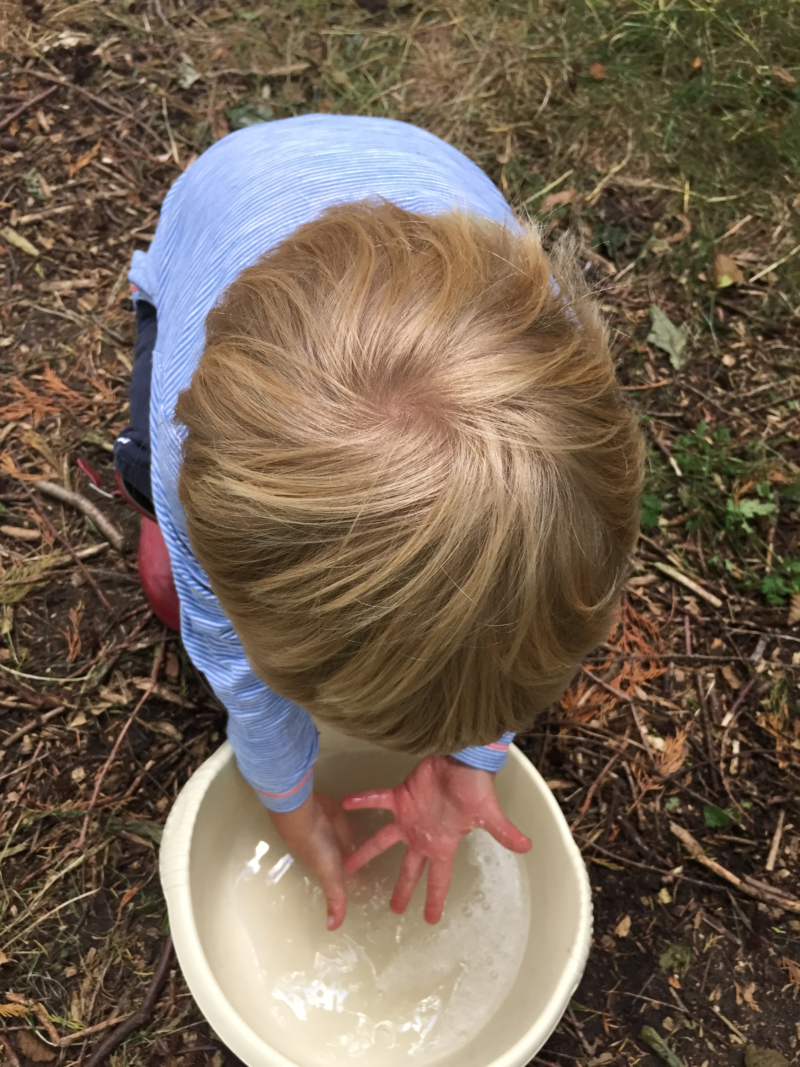

- Daily safety procedures
A daily site check will take place and the necessary risk assessment form will be completed. Tools will be checked by the Forest School leader to ensure that they are safe to use; tools will also be checked before use by the adult and child (see Tools). Before lighting a fire, we will ensure that all fire safety equipment is in place (see Fire)

- Transport
Forest school will take place on our school site. However, should we need to travel to a different location, we will ensure that appropriate transport is provided and appropriate risk assessments have been carried out. All other planning will be in accordance with our Educational Visits Policy.

- Practical skills including tools, fire and ropes
Fire
Before building and lighting a fire, all fire safety equipment must be in place:
10 litres of water
Burns kit
Fire blanket
First aid kit
Watering can
Plunge bucket
Fire retardant gloves
When having a fire, Alex Rae will take charge of the operation.
We have a designated area for fires; we have a fire pit (fire square) and a smaller fire bowl that is off the ground. The fire bowl can be used when a smaller fire is required and also helps to help reduce the ecological impact.
Open fires will be built within the fire pit; once they are lit, they will not be left unattended. Around the fire pit, there will be a fire circle. Logs for sitting will be 1.5m away from the fire. Children are not allowed to step inside the fire circle unless invited to do so by an adult. There will be no running past the fire circle – whether there is a fire or not – so as to create good practice. In order to move to a new seat, children must step out of the fire circle and walk around the outside of the log circle. (see fire risk assessment)

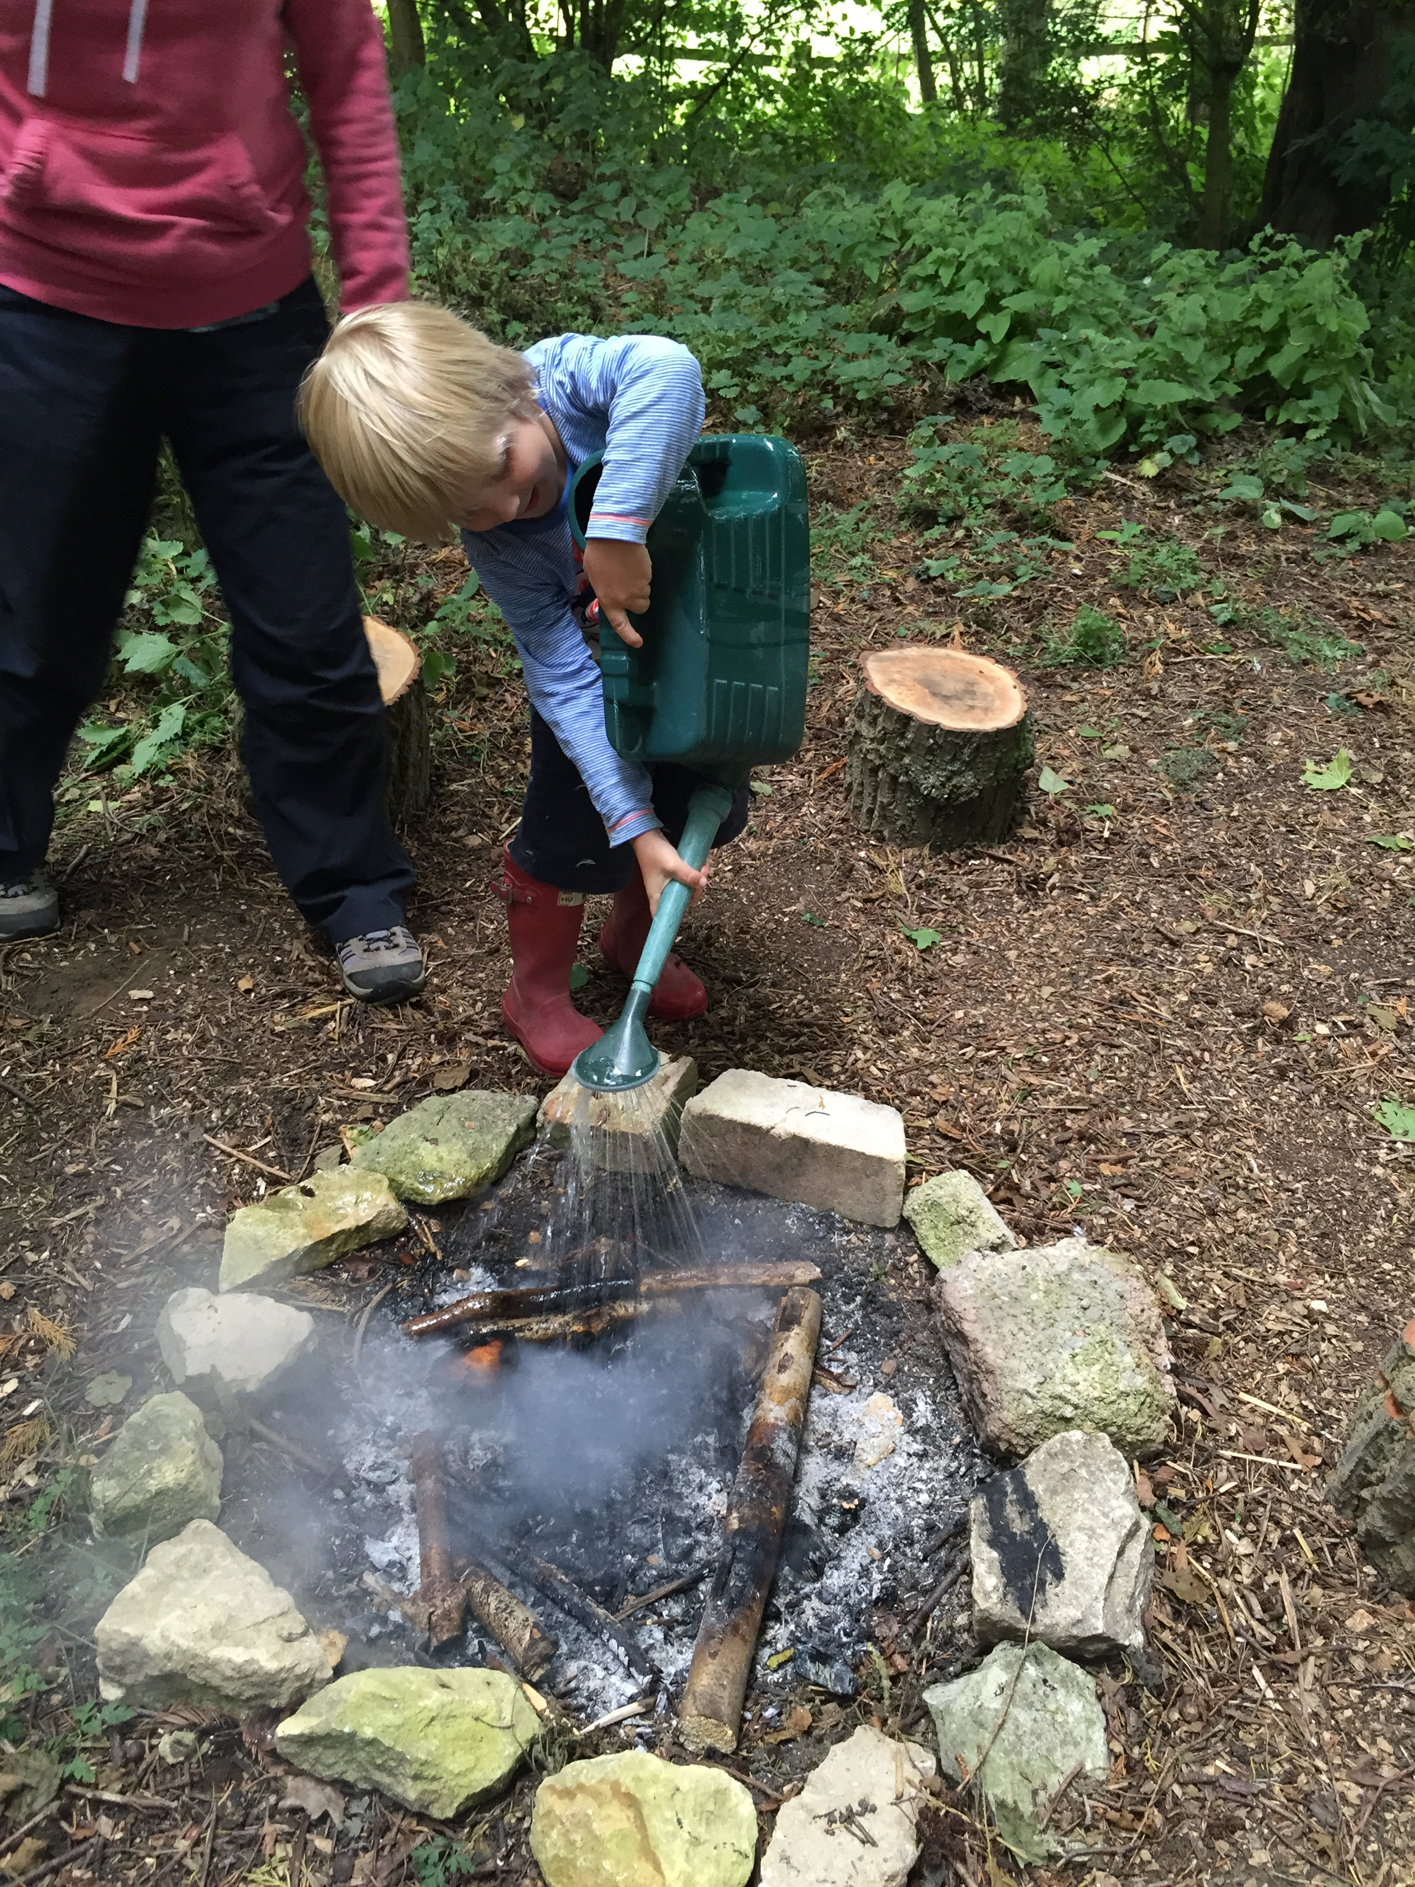

Tools
All tools have their own clear code of conduct for correct use, which will include consideration of specific personal protective equipment, correct use of a specific body posture, and consideration of the appropriate types of activity that each tool may be used for (see tool guides and risk assessments)
Tools will be kept in a bag. Only adults may take a tool out. Working with tools will take place in a designated area of the forest school site with a 1:1 ratio. The safe use of tools will be taught by Alex Rae.

Ropes
We will use ropes during Forest School sessions; children may choose to build shelters, rope swings or mobiles and will need a rope for this. We will talk through the safe use of ropes with the children and get them to come up with some golden Forest School rules for using it. When appropriate, we will model knot tying and will talk through ideas and decisions with the children.

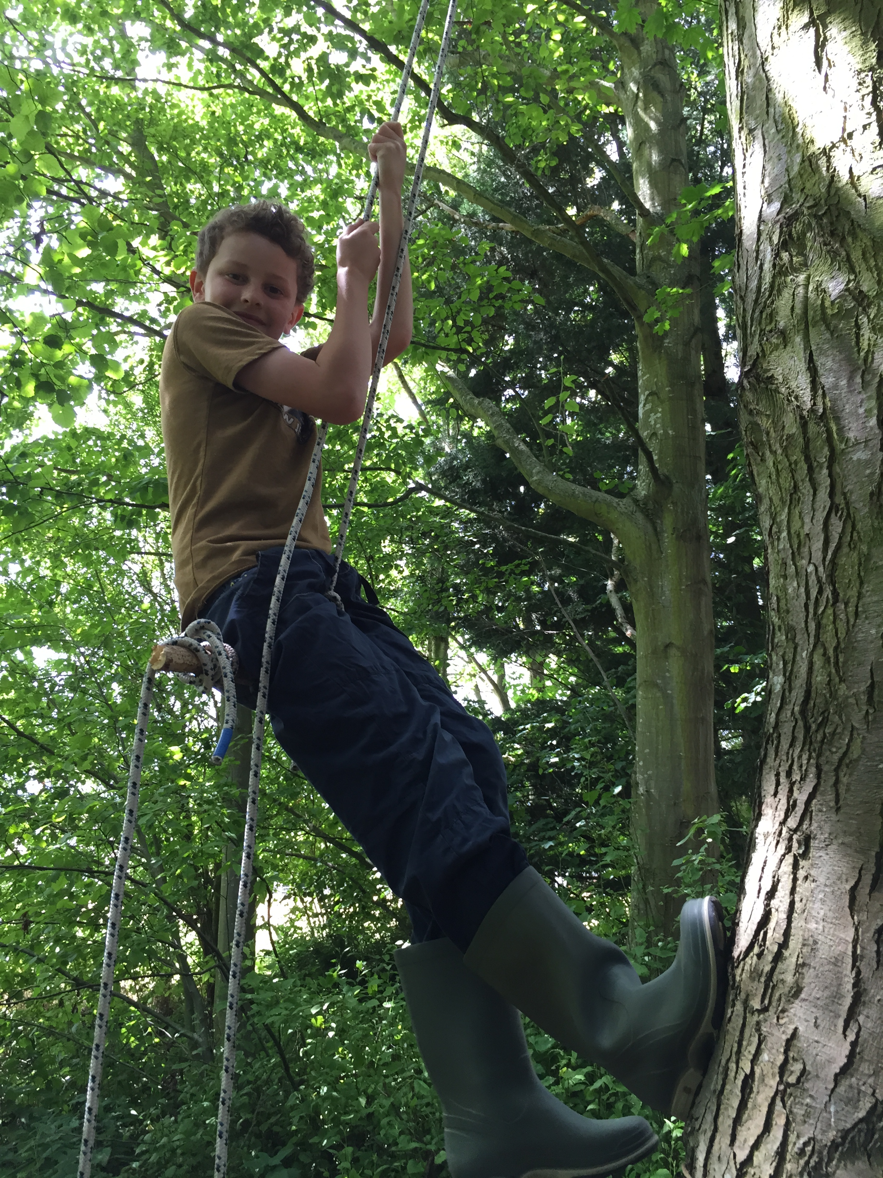

Safeguarding

Our school aims to provide a safe, caring, positive and stimulating environment that promotes the social, physical and moral development of the individual child free from discrimination or bullying where children can learn and develop happily. If a child makes a disclosure during a Forest School session, the adult should listen to the child but not ask any leading questions. Whatever the child has said should be written down as soon as possible, signed and dated by the adult and given to the Forest School leader. In line with our Safeguarding Policy, she will then pass this on to designated Teacher for Child Protection: Robyn Jones (Headteacher).

If you have any concerns regarding a child based on observations during a Forest School session, these should be written down as soon as possible, signed and dated and given to the Forest School Leader. In line with our Safeguarding Policy, the Forest School leader will then pass these concerns to designated Teacher for Child Protection: Robyn Jones (Headteacher).

Session Routines

Children will be registered and then dress appropriately (according to weather) before going outside to the Forest School Site. After a quick chat and reminder of certain rules, the children will go off to play.
If the children need to be called back, an adult will call, ‘Marco’ and the children will reply with, ‘Polo’ and stop what they are doing. They will come back to where the adult is standing.
During the afternoon, the children will be called back to have a drink and something to eat around the fire.
Before the session ends, the children will work together to tidy up and leave the site as they found it.

Monday Group
Name | Medical Information | Food Allergies | Media Permissions

Tuesday Group
Name | Medical Information | Food Allergies | Media Permissions

